**Project Design Phase-II**

**Technology Stack (Architecture & Stack)**

|  |  |
| --- | --- |
| Date | 19 October 2022 |
| Team ID | PNT2022TMID39665 |
| Project Name | Smart waste management system. |
| Maximum Marks | 4 Marks |

**Technical Architecture:**

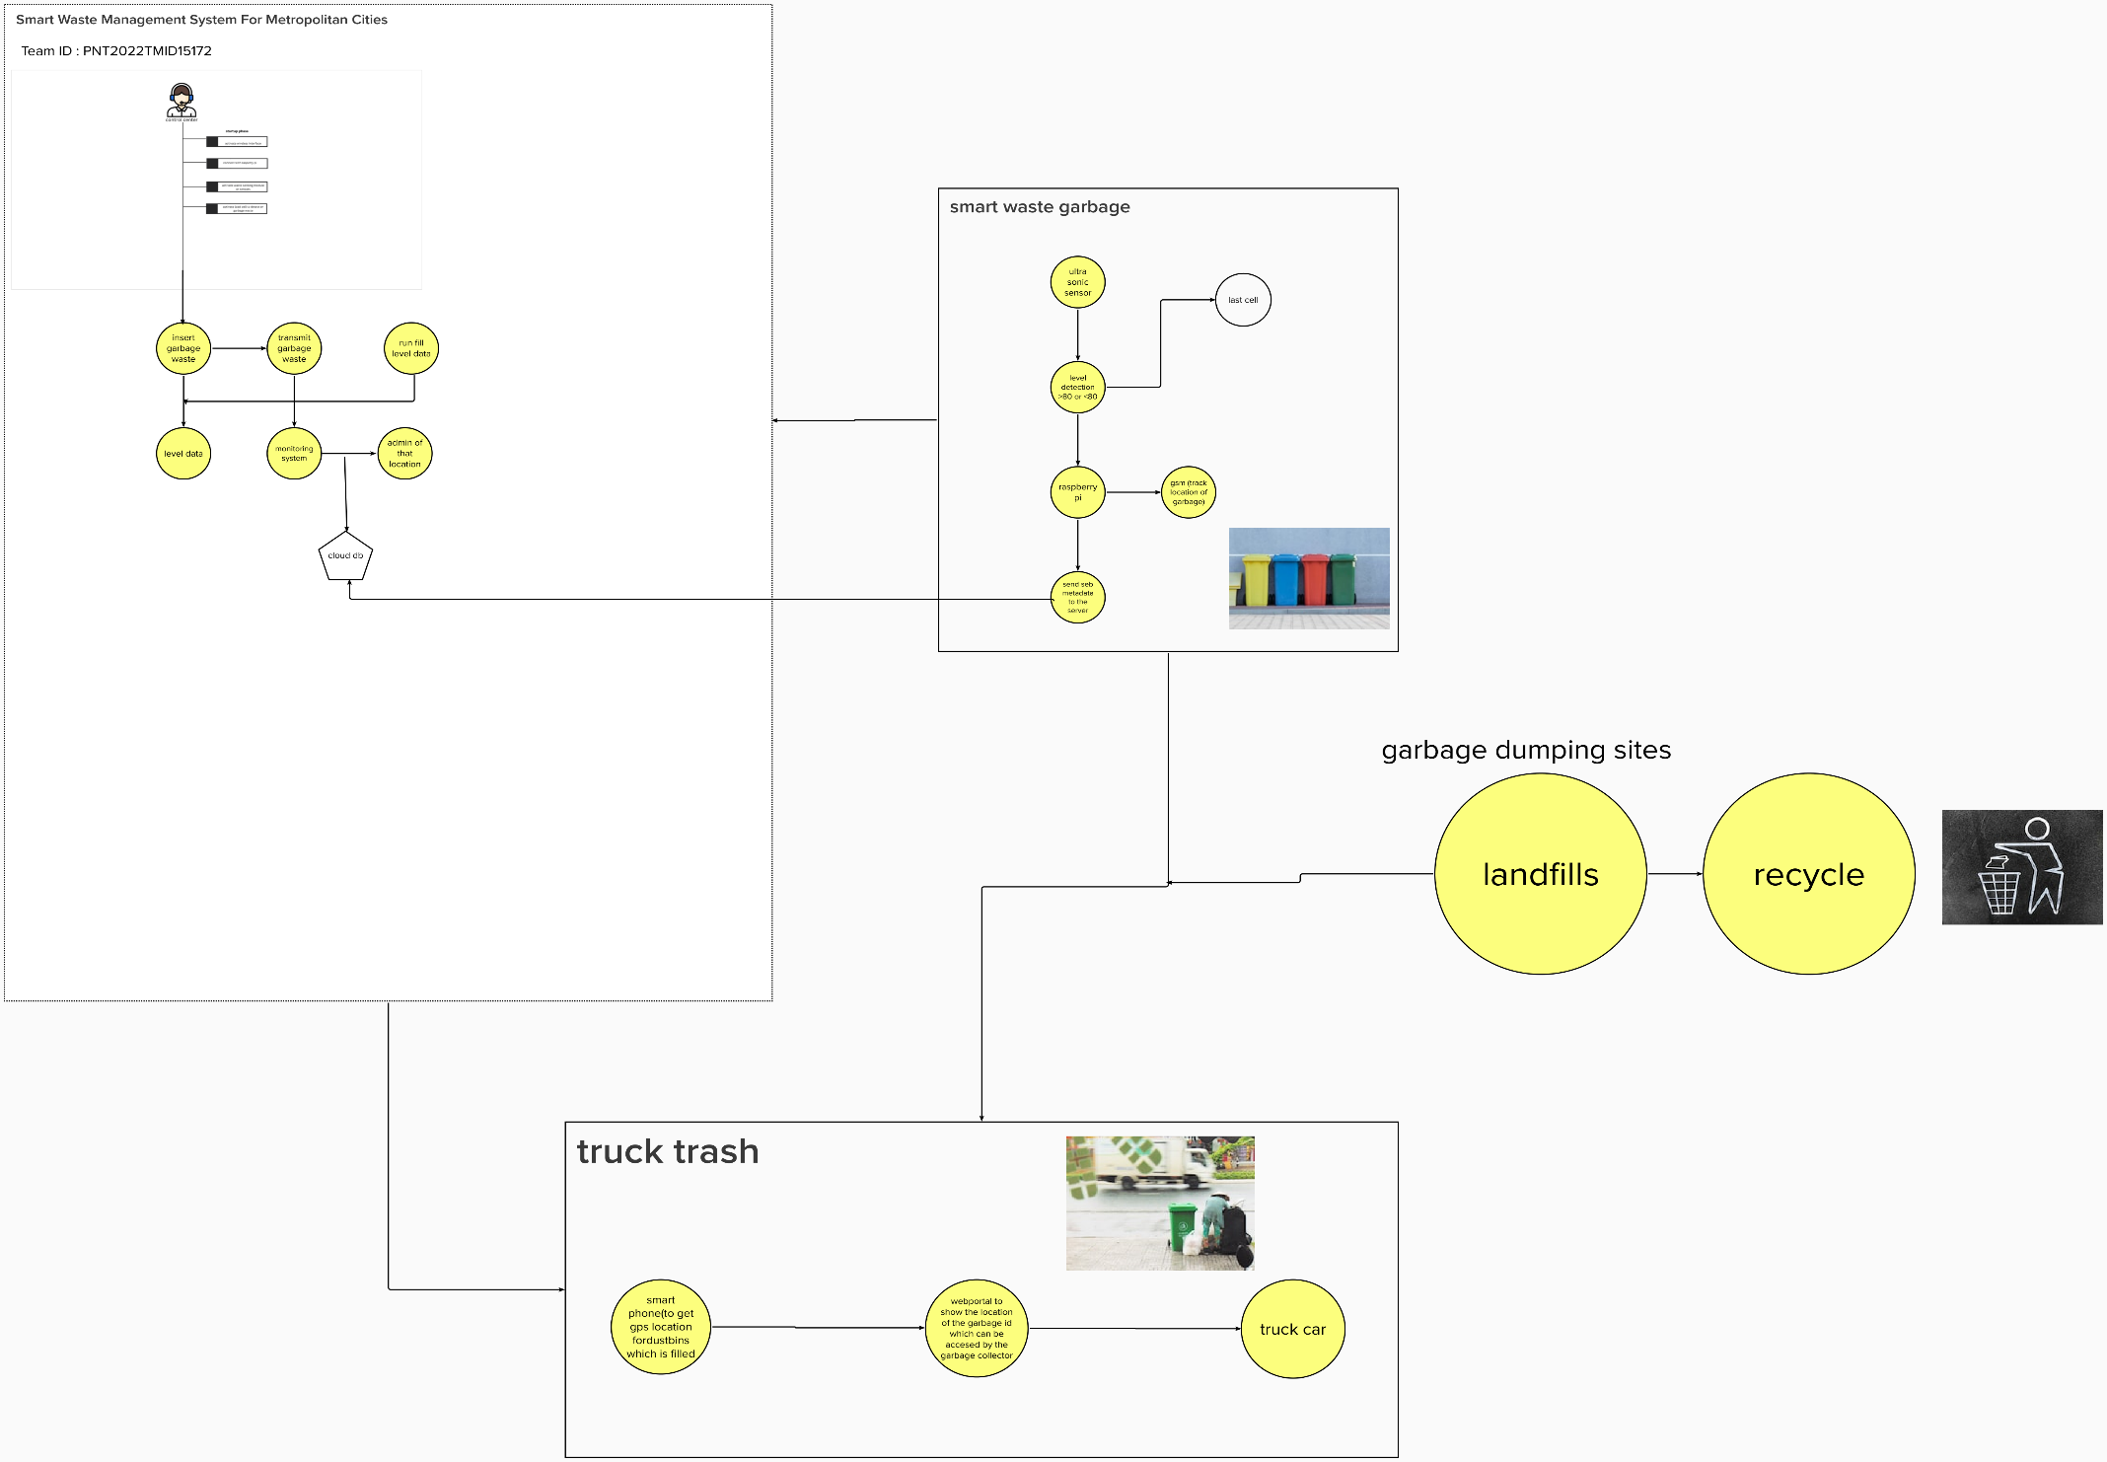

**Table-1 : Components & Technologies:**

|  |  |  |  |
| --- | --- | --- | --- |
| **S.No** | **Component** | **Description** | **Technology** |
| 1. | User  Interface | Web Portal | HTML,CSS,NodeRed,  Javascript.o r on |
| 2. | Application Logic-1 | To calculate the distance of dreck and show the real time level in web portal , information getting via ultra sonic sensor and the alert message activate with python script to web portal. | Ultrasonic sensor/ Python. |
| 3. | Application Logic-2 | To calculate the weight of the garbage and show the real time weight in web portal, this info getting via load cell and the alert message activate with python to web portal. | Load cell/Python. |
| 4. | Application Logic-3 | Getting location of the Garbage. | GSM / GPS. |
| 5. | Cloud  Database. | Database Service on Cloud | IBM DB2, IBM Cloudant etc. |
| 6. | File Storage | File storage requirements | Github,Local file system. |
| 7. | External API- 1. | Firebase is a set of hosting services for any type of | Firebase. |

|  |  |  |  |
| --- | --- | --- | --- |
| **S.No** | **Characteristics** | **Description** | **Technology** |
| 1. | Open-Source Frameworks | NodeRed,Python,IBM Simulator. | IoT |
| 2. | Security Implementations | Raspberry Pi is connected to the internet and for example used to broadcast live data, further security measures are recommended and use the  UFW(uncomplicated  Firewall). | IoT |
| 3. | Scalable Architecture | Raspberry pi:Specifications  Soc: rspi ZERO W  CPU: 32-bit computer with a 1 GHz ARMv6  RAM: 512MB  Networking: Wi-Fi  Bluetooth: Bluetooth 5.0, Bluetooth Low Energy (BLE).  Storage: MicroSD  GPIO: 40-pin GPIO header, populated | IoT |

|  |  |  |  |
| --- | --- | --- | --- |
|  |  | application. It offers NoSQL and real-time hosting of databases, content, social authentication, and notifications, or services, such as a real-time communication server. |  |
| 8. | Ultrasonic Sensor. | To throw alert message when garbage is getting full. | Distance Recognition Model. |
| 9. | Infrastructure  (Server /  Cloud) | Application Deployment on Local  System / Cloud  Local Server  Configuration:localhost  Cloud Server  Configuration:localhost,Firebase. | Localhost,Web portal. |

**Table-2: Application Characteristics:**

|  |  |  |  |
| --- | --- | --- | --- |
| **S.No** | **Characteristics** | **Description** | **Technology** |
|  |  | Ports: micro HDMI 2.0, 3.5mm analogue audio- video jack, 2x USB 2.0, 2x USB 3.0, Ethernet Dimensions: 88mm x 58mm x 19.5mm, 46g |  |
| 4. | Availability | These smart bins use sensors like ultrasonic and load cell to send alert message about the trash level recognition technology, and artificial intelligence, enabling them to automatically sort and categorize recycling litter into one of its smaller bin. | IoT. |
| 5. | Performance | Number of request:RPI manages to execute 129- 139 read requests per second.  Use of Cache:512mb  Use of CDN’s:Real time | IoT/Web portal. |